Alexander Baldree
05/20/26
Module 11.2 Assignment
CSD420

GitHub Link:
https://github.com/Panda-Alex21687/CSD420/tree/main/Module 11
Maven Library Setup:
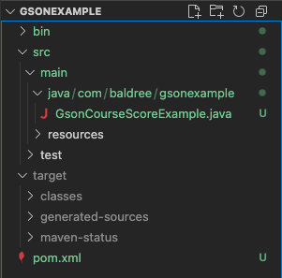

Maven / JavaFX
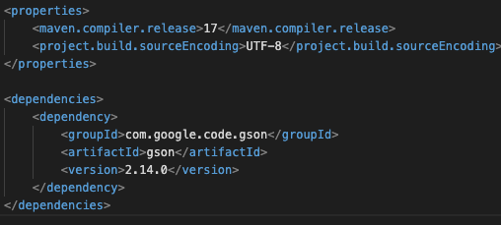
Program run/ Output Build
